**DATA FLOW DIAGRAM**

Context diagram for LIC management system

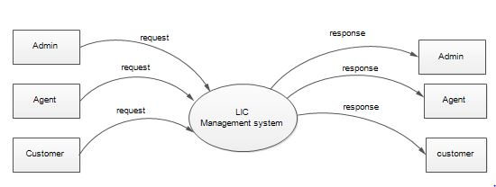

First level DFD for LIC Management System-Admin

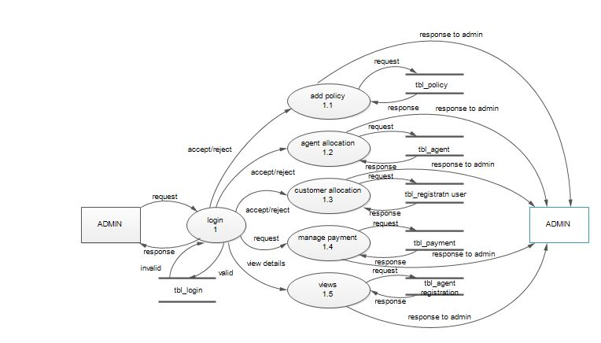

First level DFD for LIC Management System-Agent

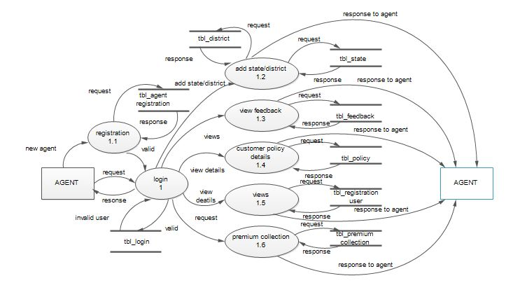

First level DFD for LIC Management System-Customer

